NAME:M.ABI SHREE
REG NO:192424405 CSA0318 - LAB EXPERIMENTS
EX.NO:1 REVERSING A 32 BIT SIGNED INTEGERS
#include <stdio.h>
#include <limits.h>
int main() {
int n, rev = 0, digit;
printf("Enter a 32-bit signed integer: ");
scanf("%d", &n);
while (n != 0) {
digit = n % 10;
n = n / 10;
if (rev > INT_MAX / 10 || rev < INT_MIN / 10) {
printf("Overflow occurred! Cannot reverse.\n");
return 0;
}
rev = rev * 10 + digit;
}
printf("Reversed Integer = %d\n", rev);
return 0;
}

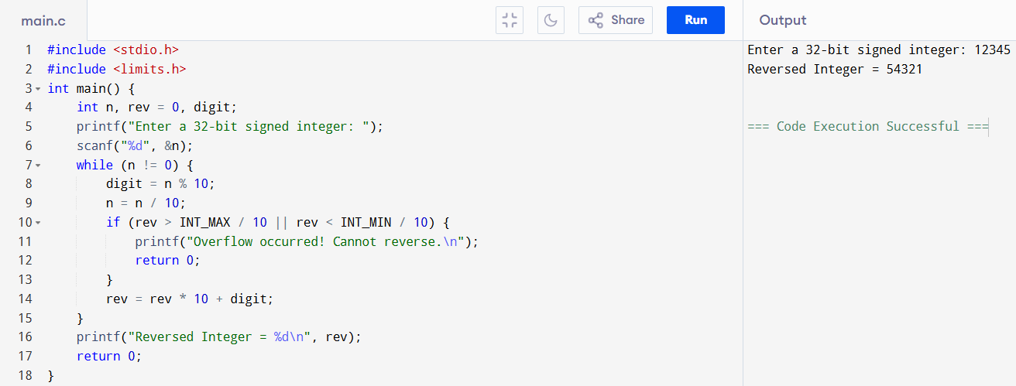
EX.NO:2 TO CHECK FOR A VALID STRING
#include <stdio.h>
#include <ctype.h>
int main() {
char str[100];
int i, valid = 1;
printf("Enter a string: ");
gets(str);
for(i = 0; str[i] != '\0'; i++) {
if(!isalnum(str[i])) {
valid = 0;
break;
}
}
if(valid)
printf("Valid String\n");
else
printf("Invalid String\n");
return 0;
}

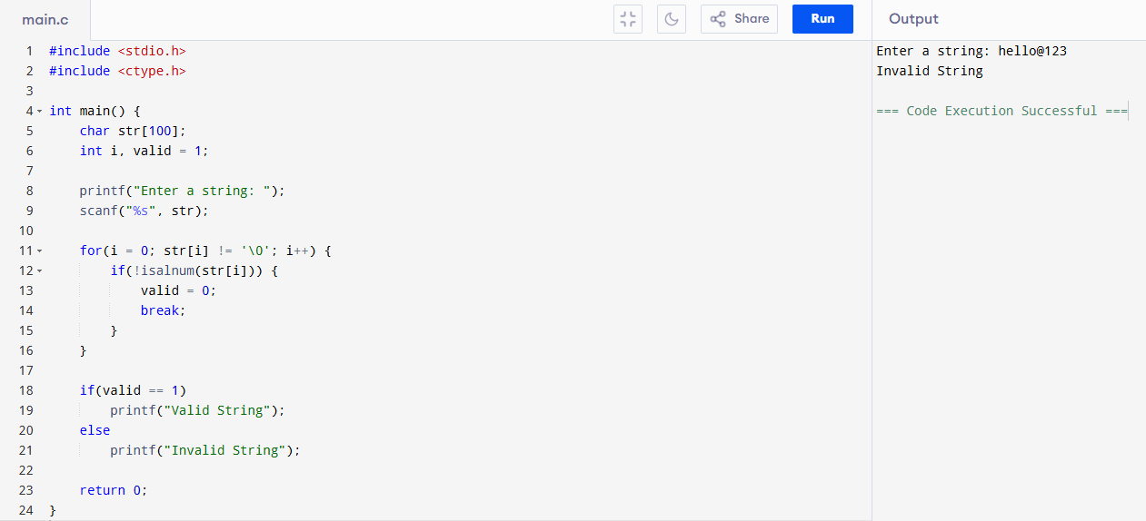

EX.NO:3 LINEAR SEARCH FOR STUDENT REGISTER NUMBER
#include <stdio.h>
int main() {
int reg[100], n, key, i, found = 0;
printf("Enter number of students: ");
scanf("%d", &n);
printf("Enter %d registration numbers:\n", n);
for(i = 0; i < n; i++) {
scanf("%d", &reg[i]);
}
printf("Enter registration number to search: ");
scanf("%d", &key);
for(i = 0; i < n; i++) {
if(reg[i] == key) {
found = 1;
break;
}
}
if(found == 1)
printf("Registration number found at position %d\n", i + 1);
else
printf("Registration number not found\n");
return 0;
}
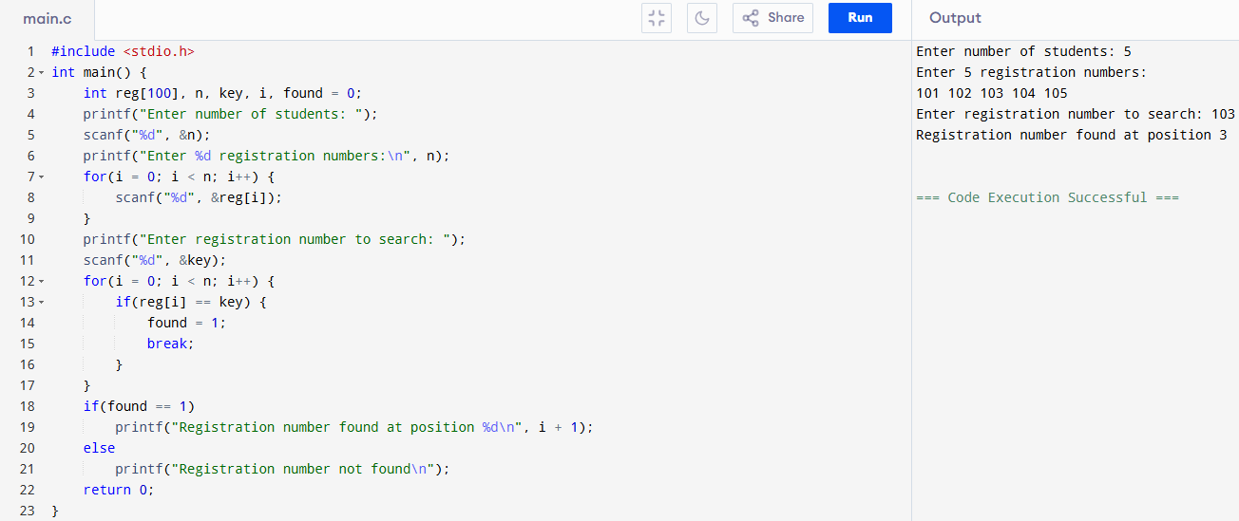
EX.NO:4 BINARY SEARCH FOR STUDENT REGISTER NUMBER
#include <stdio.h>
int main() {
int reg[100], n, key, low, high, mid, found = 0, i;
printf("Enter number of students: ");
scanf("%d", &n);
printf("Enter %d registration numbers (in sorted order):\n", n);
for(i = 0; i < n; i++)
scanf("%d", &reg[i]);
printf("Enter registration number to search: ");
scanf("%d", &key);
low = 0;
high = n - 1;
while(low <= high) {
mid = (low + high) / 2;
if(reg[mid] == key) {
found = 1;
break;
}
else if(key < reg[mid])
high = mid - 1;
else
low = mid + 1;
}
if(found == 1)
printf("Registration number found at position %d\n", mid + 1);
else
printf("Registration number not found\n");
return 0;
}
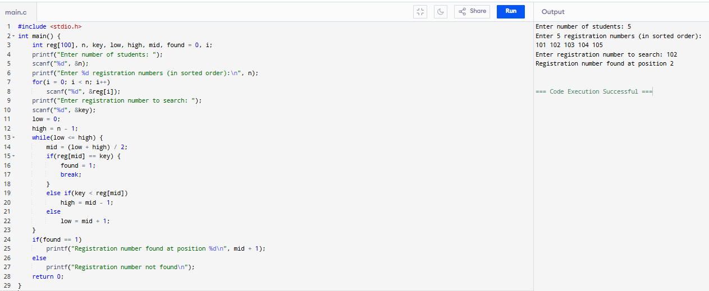

EX.NO:5 IDENTIFY LOCATION OF ELEMENT IN GIVEN ARRAY
#include <stdio.h>
int main() {
int a[50], n, key, i, found = 0;
printf("Enter number of elements: ");
scanf("%d", &n);
printf("Enter %d elements:\n", n);
for(i = 0; i < n; i++)
scanf("%d", &a[i]);
printf("Enter element to find: ");
scanf("%d", &key);
for(i = 0; i < n; i++) {
if(a[i] == key) {
printf("Element found at position %d\n", i + 1);
found = 1;
break;
}
}
if(!found)
printf("Element not found\n");
return 0;
}
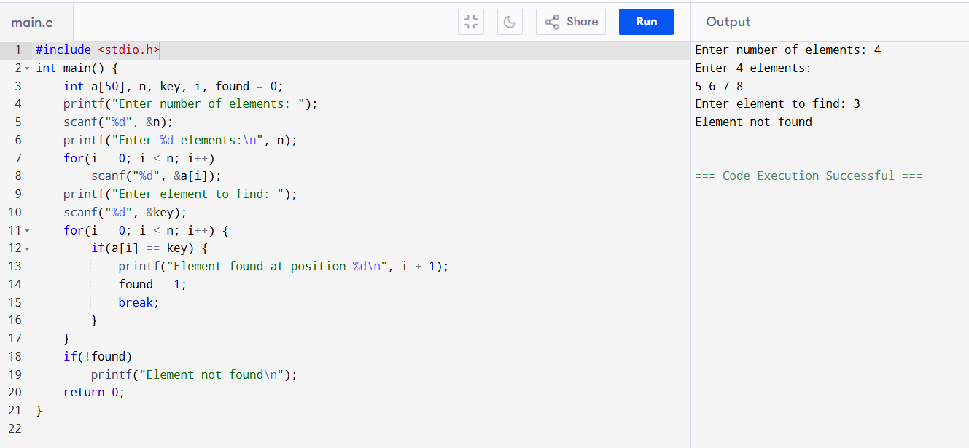
EX.NO:6 TO PRINT ODD AND EVEN VALUES
#include <stdio.h>
int main() {
int a[50], n, i;
printf("Enter number of elements: ");
scanf("%d", &n);
printf("Enter %d elements:\n", n);
for(i = 0; i < n; i++)
scanf("%d", &a[i]);
printf("\nEven numbers: ");
for(i = 0; i < n; i++) {
if(a[i] % 2 == 0)
printf("%d ", a[i]);
}
printf("\nOdd numbers: ");
for(i = 0; i < n; i++) {
if(a[i] % 2 != 0)
printf("%d ", a[i]);
}
return 0;
}
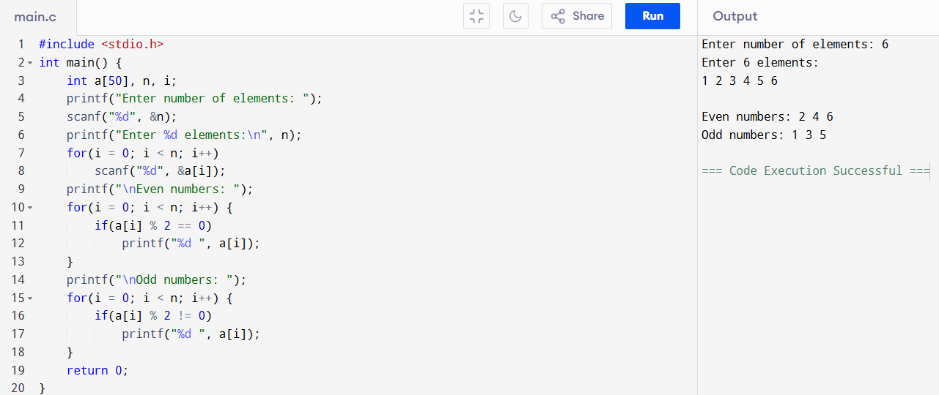
EX.NO:7 SUM OF FIBONACCI SERIES
#include <stdio.h>
int main() {
int n, a = 0, b = 1, c, i, sum = 0;
printf("Enter number of terms: ");
scanf("%d", &n);
printf("Fibonacci Series: ");
for(i = 1; i <= n; i++) {
printf("%d ", a);
sum += a;
c = a + b;
a = b;
b = c;
}
printf("\nSum of Fibonacci Series = %d\n", sum);
return 0;
}
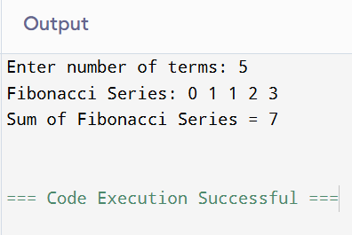
EX.NO:8 FINDING FACTORIAL OF A NUMBER
#include <stdio.h>
int main() {
int n, i;
long long fact = 1; // to handle large numbers
printf("Enter a number: ");
scanf("%d", &n);
if (n < 0)
printf("Factorial of negative number is not possible.\n");
else {
for (i = 1; i <= n; i++) {
fact = fact * i;
}
printf("Factorial of %d = %lld\n", n, fact);
}
return 0;
}
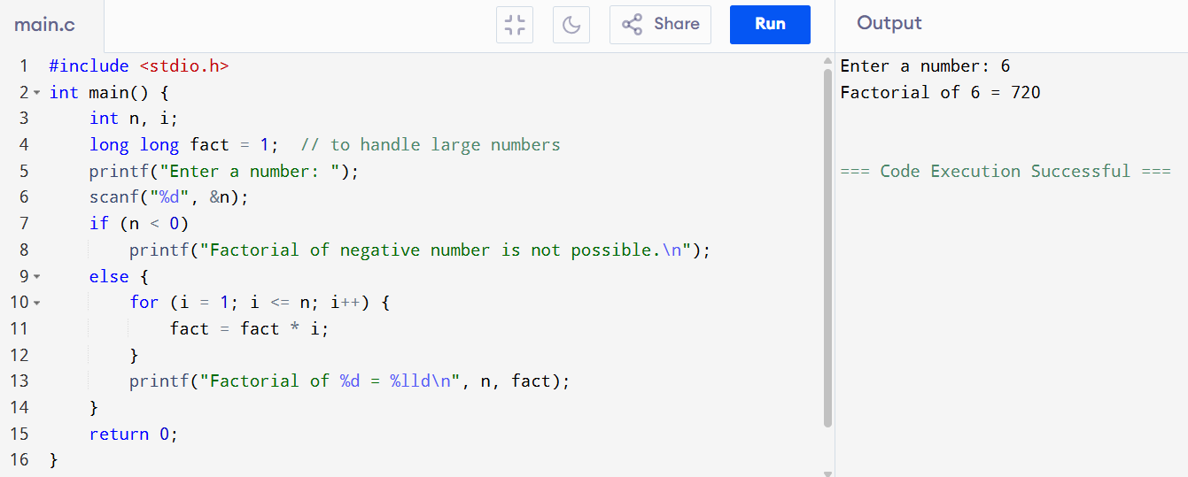
EX.NO:9 ARRAY SEARCH – LINEAR & BINARY SEARCH
#include <stdio.h>
int main() {
int a[50], n, key, i, low, high, mid, found = 0;
printf("Enter number of elements: ");
scanf("%d", &n);
printf("Enter %d elements (sorted for binary search):\n", n);
for(i = 0; i < n; i++)
scanf("%d", &a[i]);
printf("Enter element to search: ");
scanf("%d", &key);
for(i = 0; i < n; i++) {
if(a[i] == key) {
printf("Found by Linear Search at position %d\n", i + 1);
found = 1;
break;
}
}
if(!found)
printf("Not found by Linear Search\n");
low = 0;
high = n - 1;
found = 0;
while(low <= high) {
mid = (low + high) / 2;
if(a[mid] == key) {
printf("Found by Binary Search at position %d\n", mid + 1);
found = 1;
break;
} else if(key < a[mid])
high = mid - 1;
else
low = mid + 1;
}
if(!found)
printf("Not found by Binary Search\n");
return 0;
}
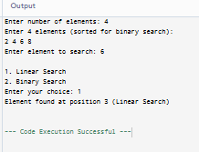
EX.NO:10 TO PRINT THE REPEATED CHARACTERS IN AN ARRAY
#include <stdio.h>
int main() {
char a[50];
int n, i, j;
printf("Enter number of characters: ");
scanf("%d", &n);
printf("Enter %d characters:\n", n);
for(i = 0; i < n; i++)
scanf(" %c", &a[i]);
printf("\nRepeated characters and their indexes:\n");
for(i = 0; i < n; i++) {
for(j = i + 1; j < n; j++) {
if(a[i] == a[j]) {
printf("Character '%c' repeated at indexes %d and %d\n", a[i], i, j);
}
}
}
return 0;
}
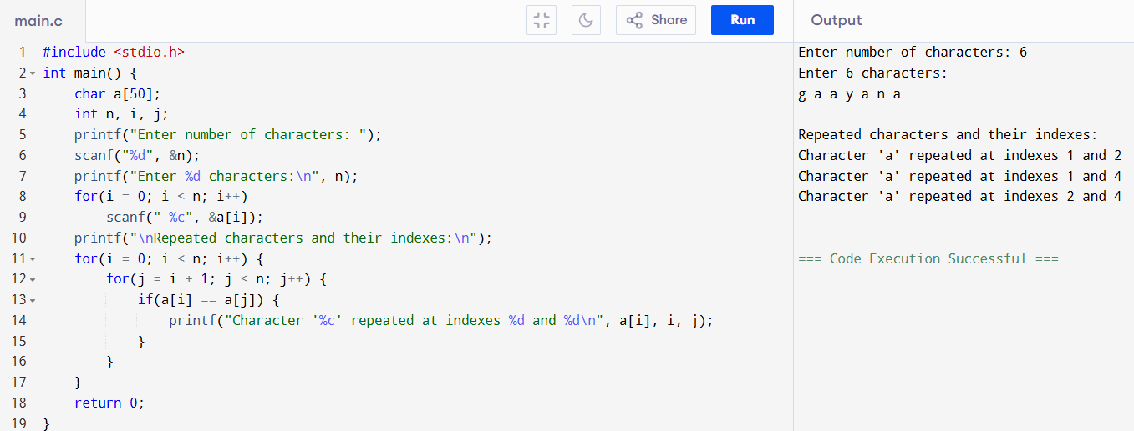

EX.NO:11 FREQUENTLY REPEATED NUMBERS COUNT FROM AN ARRAY
#include <stdio.h>
int main() {
int a[50], n, i, j, count, maxCount = 0, freqNum;
printf("Enter number of elements: ");
scanf("%d", &n);
printf("Enter %d numbers:\n", n);
for(i = 0; i < n; i++)
scanf("%d", &a[i]);
for(i = 0; i < n; i++) {
count = 1;
for(j = i + 1; j < n; j++) {
if(a[i] == a[j])
count++;
}
if(count > maxCount) {
maxCount = count;
freqNum = a[i];
}
}
printf("\nMost frequently repeated number: %d\n", freqNum);
printf("It is repeated %d times\n", maxCount);
return 0;
}
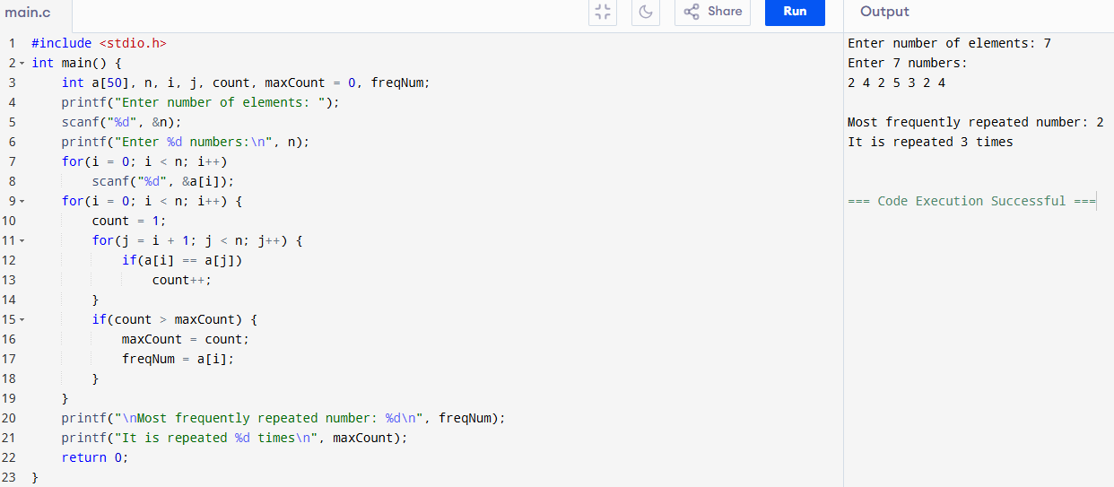
EX.NO:12 SUM OF ROW & COLUMN IN AN ARRAY
#include <stdio.h>
int main() {
int a[10][10], r, c, i, j, sum;
printf("Enter number of rows and columns: ");
scanf("%d %d", &r, &c);
printf("Enter the elements of the matrix:\n");
for(i = 0; i < r; i++) {
for(j = 0; j < c; j++) {
scanf("%d", &a[i][j]);
}
}
for(i = 0; i < r; i++) {
sum = 0;
for(j = 0; j < c; j++)
sum += a[i][j];
printf("Sum of Row %d = %d\n", i + 1, sum);
}
for(j = 0; j < c; j++) {
sum = 0;
for(i = 0; i < r; i++)
sum += a[i][j];
printf("Sum of Column %d = %d\n", j + 1, sum);
}
return 0;
}
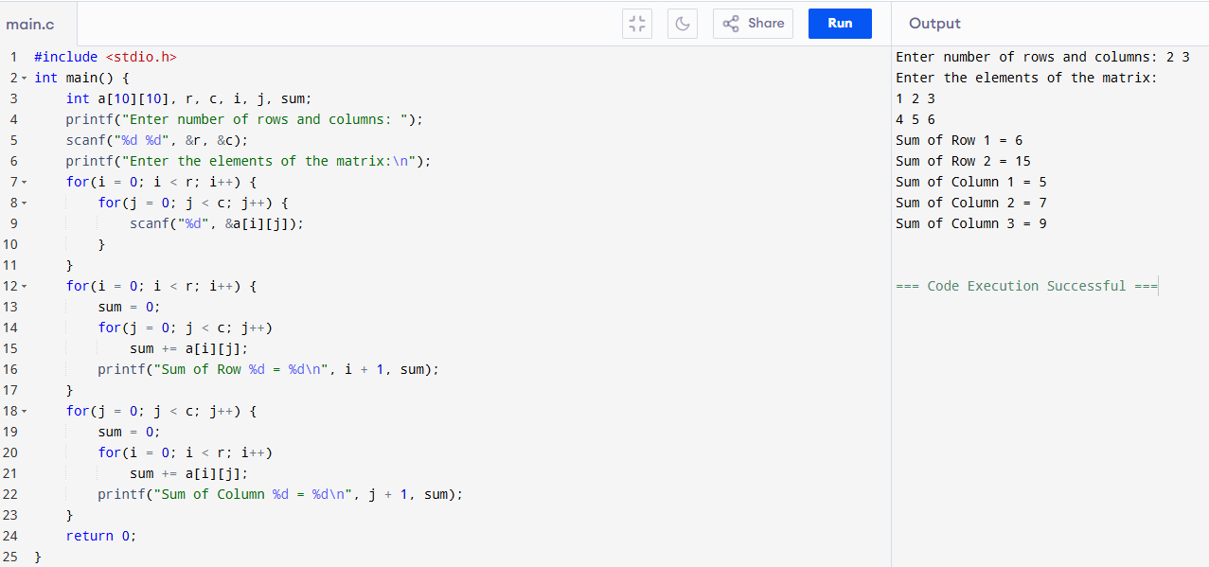
EX.NO:13 CHECK FOR ELEMENTS REPEATED TWICE – ARRAY
#include <stdio.h>
int main() {
int a[50], n, i, j, count;
printf("Enter number of elements: ");
scanf("%d", &n);
printf("Enter %d elements:\n", n);
for(i = 0; i < n; i++)
scanf("%d", &a[i]);
printf("\nElements repeated twice:\n");
for(i = 0; i < n; i++) {
count = 1;
for(j = i + 1; j < n; j++) {
if(a[i] == a[j]) {
count++;
}
}
if(count == 2) {
printf("%d\n", a[i]);
}
}
return 0;
}
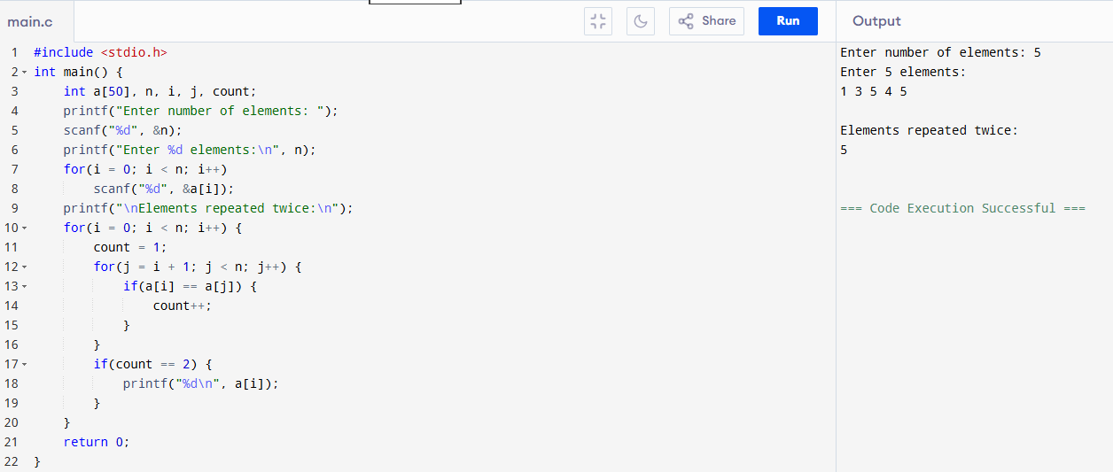
EX.NO:14 2D MATRIX TO PRINT LARGEST ELEMENT
#include <stdio.h>
int main() {
int a[10][10], r, c, i, j, max;
printf("Enter number of rows and columns: ");
scanf("%d %d", &r, &c);
printf("Enter the elements of the matrix:\n");
for(i = 0; i < r; i++) {
for(j = 0; j < c; j++) {
scanf("%d", &a[i][j]);
}
}
max = a[0][0]; // assume first element is largest
for(i = 0; i < r; i++) {
for(j = 0; j < c; j++) {
if(a[i][j] > max)
max = a[i][j];
}
}
printf("\nLargest element in the matrix = %d\n", max);
return 0;
}
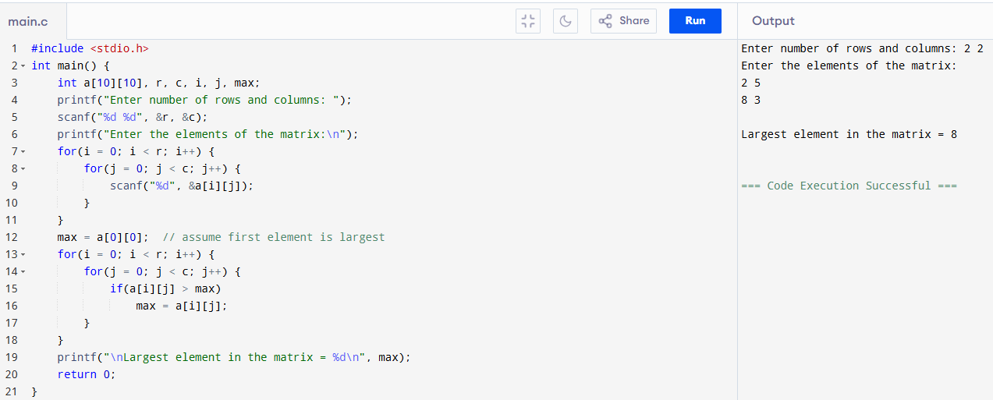
EX.NO:15 3D MATRIX TO PRINT ADD, SUB, MUL, TRANSPOSE
#include <stdio.h>
int main() {
int A[3][3], B[3][3], C[3][3], i, j, k, sum;
printf("Enter 1st 3x3 matrix:\n");
for(i=0;i<3;i++)
for(j=0;j<3;j++)
scanf("%d",&A[i][j]);
printf("Enter 2nd 3x3 matrix:\n");
for(i=0;i<3;i++)
for(j=0;j<3;j++)
scanf("%d",&B[i][j]);
printf("\nAddition:\n");
for(i=0;i<3;i++){for(j=0;j<3;j++){C[i][j]=A[i][j]+B[i][j];printf("%d ",C[i][j]);}printf("\n");}
printf("\nSubtraction:\n");
for(i=0;i<3;i++){for(j=0;j<3;j++){C[i][j]=A[i][j]-B[i][j];printf("%d ",C[i][j]);}printf("\n");}
printf("\nMultiplication:\n");
for(i=0;i<3;i++){for(j=0;j<3;j++){sum=0;for(k=0;k<3;k++)sum+=A[i][k]*B[k][j];printf("%d ",sum);}printf("\n");}
printf("\nTranspose of A:\n");
for(i=0;i<3;i++){for(j=0;j<3;j++)printf("%d ",A[j][i]);printf("\n");}
return 0;
}
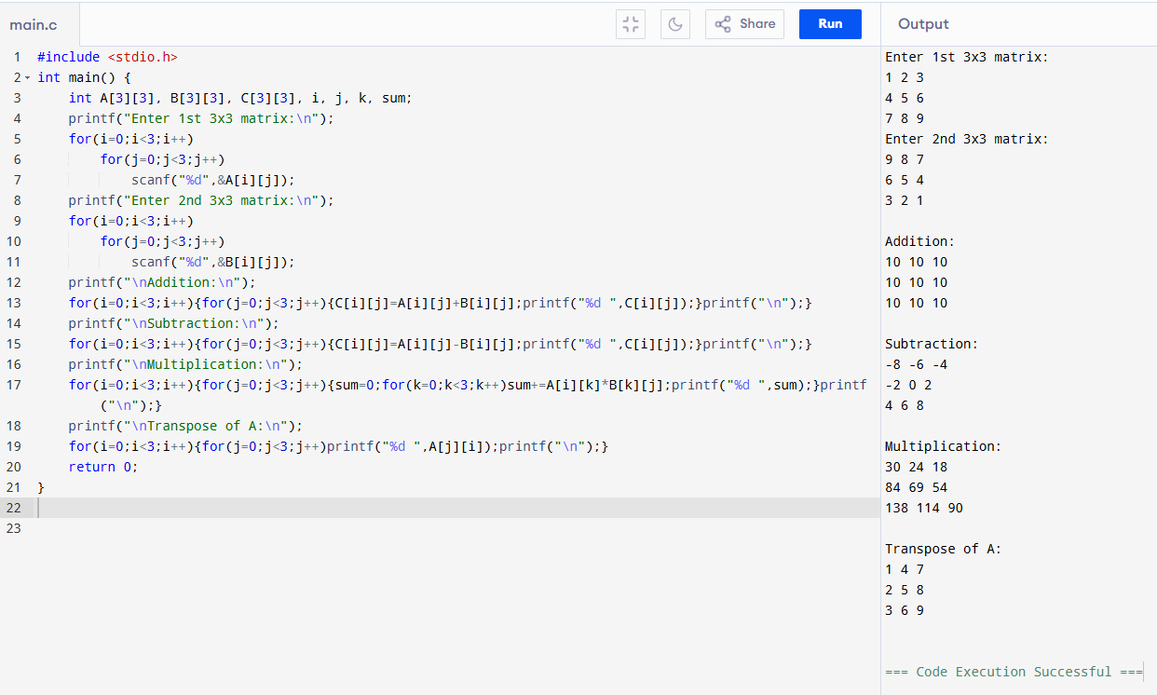

EX.NO:16 SINGLE LINKED LIST
#include <stdio.h>
#include <stdlib.h>
struct node {
int data;
struct node *next;
};
int main() {
struct node *head = NULL, *temp, *newnode;
int n, i;
printf("Enter number of nodes: ");
scanf("%d", &n);
for(i = 0; i < n; i++) {
newnode = (struct node*)malloc(sizeof(struct node));
printf("Enter data for node %d: ", i + 1);
scanf("%d", &newnode->data);
newnode->next = NULL;
if(head == NULL)
head = temp = newnode;
else {
temp->next = newnode;
temp = newnode;
}
}
printf("\nLinked List Elements: ");
temp = head;
while(temp != NULL) {
printf("%d ", temp->data);
temp = temp->next;
}
return 0;
}
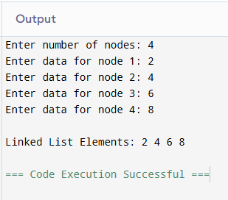
EXP NO17: WRITE A C PROGRAM TO IMPLEMENT STACK OPERATION IN ARRAY[PUSH]
#include <stdio.h>
#define MAX 5
int main() {
int stack[MAX], top = -1, item, i, n;
printf("Enter number of elements to push (max %d): ", MAX);
scanf("%d", &n);
for(i = 0; i < n; i++) {
if(top == MAX - 1)
printf("Stack Overflow! Cannot push more elements.\n");
else {
printf("Enter element to push: ");
scanf("%d", &item);
top++;
stack[top] = item;
printf("Element %d pushed into stack.\n", item);
}
}
printf("\nStack Elements (Top to Bottom): ");
for(i = top; i >= 0; i--)
printf("%d ", stack[i]);
return 0;
}
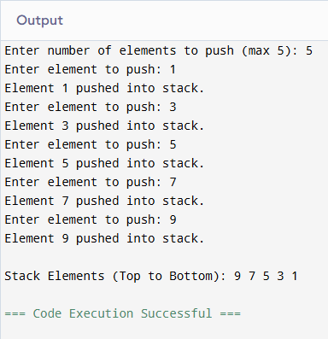
EXP NO18: WRITE A C PROGRAM TO IMPLEMENT STACK OPERATIONIN ARRAY[POP]
#include <stdio.h>
#define MAX 5
int main() {
int stack[MAX], top = -1, item, n, i;
printf("Enter number of elements to push (max %d): ", MAX);
scanf("%d", &n);
for(i = 0; i < n; i++) {
printf("Enter element: ");
scanf("%d", &item);
if(top == MAX - 1)
printf("Stack Overflow!\n");
else
stack[++top] = item;
}
printf("\nStack before POP: ");
for(i = top; i >= 0; i--)
printf("%d ", stack[i]);
if(top == -1)
printf("\n\nStack Underflow! No elements to pop.\n");
else {
item = stack[top--];
printf("\n\nPopped element = %d\n", item);
}
printf("\nStack after POP: ");
for(i = top; i >= 0; i--)
printf("%d ", stack[i]);
return 0;
}
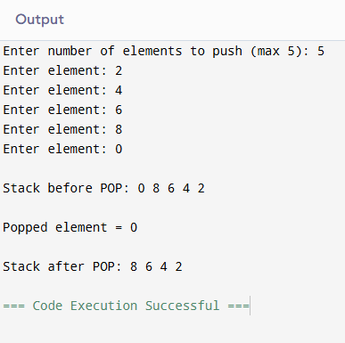
EXP NO19: WRITE A C PROGRAM TO IMPLEMENT STACK OPERATION IN ARRAY[DISPLAY]
#include <stdio.h>
#define MAX 5
int main() {
int stack[MAX], top = -1, item, n, i;
printf("Enter number of elements to push (max %d): ", MAX);
scanf("%d", &n);
for(i = 0; i < n; i++) {
if(top == MAX - 1)
printf("Stack Overflow!\n");
else {
printf("Enter element: ");
scanf("%d", &item);
stack[++top] = item;
}
}
printf("\n--- Stack Display ---\n");
if(top == -1)
printf("Stack is empty\n");
else {
printf("Stack elements (Top to Bottom): ");
for(i = top; i >= 0; i--)
printf("%d ", stack[i]);
printf("\n");
}
return 0;
}
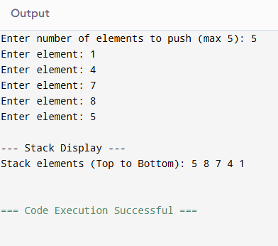

EXP NO20: WRITE A C PROGRAM TO IMPLEMENT STACK OPERATION IN LINKED LIST[PUSH]
#include <stdio.h>
#include <stdlib.h>
struct node {
int data;
struct node *next;
};
int main() {
struct node *top = NULL, *newnode;
int n, i, item;
printf("Enter number of elements to push: ");
scanf("%d", &n);
for(i = 0; i < n; i++) {
newnode = (struct node*)malloc(sizeof(struct node));
printf("Enter element to push: ");
scanf("%d", &item);
newnode->data = item;
newnode->next = top; // Link to previous top
top = newnode; // Move top to new node
}

printf("\nStack elements (Top to Bottom): ");
struct node *temp = top;
while(temp != NULL) {
printf("%d ", temp->data);
temp = temp->next;
}
return 0;
}
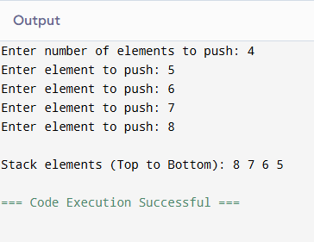
EXP NO.21: WRITE A C PROGRAM TO IMPLEMENT STACK OPERATION IN LINKED LIST[POP]
#include <stdio.h>
#include <stdlib.h>
struct node {
int data;
struct node *next;
};
int main() {
struct node *top = NULL, *temp, *newnode;
int n, i, item;
printf("Enter number of elements to push: ");
scanf("%d", &n);
for(i = 0; i < n; i++) {
newnode = (struct node*)malloc(sizeof(struct node));
printf("Enter element to push: ");
scanf("%d", &item);
newnode->data = item;
newnode->next = top;
top = newnode;
}
if(top == NULL)
printf("\nStack Underflow! No elements to pop.\n");
else {
temp = top;
printf("\nPopped element = %d\n", temp->data);
top = top->next;
free(temp);
}
printf("\nStack after POP (Top to Bottom): ");
temp = top;
if(temp == NULL)
printf("Stack is empty\n");
else {
while(temp != NULL) {
printf("%d ", temp->data);
temp = temp->next;
}
}
return 0;
}
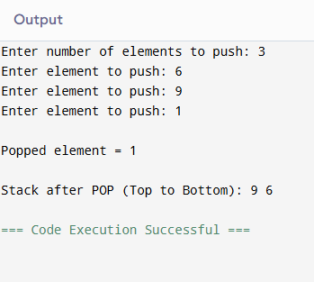
EXP NO22: WRITE A C PROGRAM TO IMPLEMENT STACK OPERATION IN LINKED LIST[DISPLAY]
#include <stdio.h>
#include <stdlib.h>
struct node {
int data;
struct node *next;
};
int main() {
struct node *top = NULL, *newnode, *temp;
int n, i, item;
printf("Enter number of elements to push: ");
scanf("%d", &n);
for(i = 0; i < n; i++) {
newnode = (struct node*)malloc(sizeof(struct node));
printf("Enter element: ");
scanf("%d", &item);
newnode->data = item;
newnode->next = top;
top = newnode;
}
printf("\n--- Stack Display ---\n");
if(top == NULL)
printf("Stack is empty.\n");
else {
temp = top;
printf("Stack elements (Top to Bottom): ");
while(temp != NULL) {
printf("%d ", temp->data);
temp = temp->next;
}
printf("\n");
}
return 0;
}
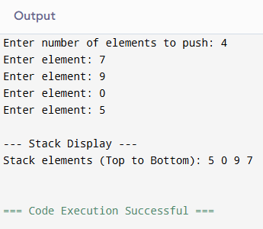
EX.NO:23 IMPLEMENT A C PROGRAM TO PRINT NO OF NODES IN THE GIVEN LINKED LIST
#include <stdio.h>
#include <stdlib.h>
struct node {
int data;
struct node *next;
};
int main() {
struct node *head = NULL, *newnode, *temp;
int n, i, count = 0;
printf("Enter number of nodes: ");
scanf("%d", &n);
for(i = 0; i < n; i++) {
newnode = (struct node*)malloc(sizeof(struct node));
printf("Enter data for node %d: ", i + 1);
scanf("%d", &newnode->data);
newnode->next = NULL;
if(head == NULL)
head = temp = newnode;
else {
temp->next = newnode;
temp = newnode;
}
}
temp = head;
while(temp != NULL) {
count++;
temp = temp->next;
}
printf("\nTotal number of nodes = %d\n", count);
return 0;
}
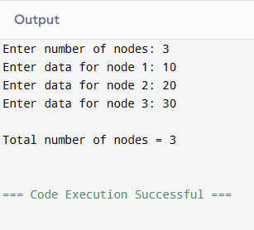

EX.NO:24 IMPLEMENT A C PROGRAM TO PERFORM PALINDROME USING SLL
#include <stdio.h>
#include <stdlib.h>
struct node {
int data;
struct node *next;
};
int main() {
struct node *head = NULL, *newnode, *temp;
int n, i, arr[100], count = 0, flag = 1;
printf("Enter number of nodes: ");
scanf("%d", &n);
for(i = 0; i < n; i++) {
newnode = (struct node*)malloc(sizeof(struct node));
printf("Enter data for node %d: ", i + 1);
scanf("%d", &newnode->data);
newnode->next = NULL;

if(head == NULL)
head = temp = newnode;
else {
temp->next = newnode;
temp = newnode;
}
}
temp = head;
while(temp != NULL) {
arr[count++] = temp->data;
temp = temp->next;
}
for(i = 0; i < count / 2; i++) {
if(arr[i] != arr[count - i - 1]) {
flag = 0;
break;
}
}
if(flag == 1)
printf("\nThe linked list is a Palindrome.\n");
else
printf("\nThe linked list is NOT a Palindrome.\n");

return 0;
}
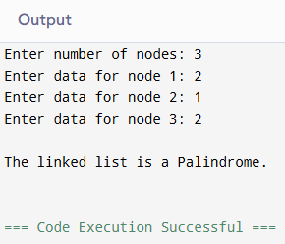
EX.NO:25 IMPLEMENT A C PROGRAM TO INTERSECT SLL
#include <stdio.h>
#include <stdlib.h>
struct node {
int data;
struct node *next;
};
struct node* createList(int n) {
struct node *head = NULL, *newnode, *temp;
int i, val;
for(i = 0; i < n; i++) {
newnode = (struct node*)malloc(sizeof(struct node));
printf("Enter data for node %d: ", i + 1);
scanf("%d", &val);
newnode->data = val;
newnode->next = NULL;
if(head == NULL)
head = temp = newnode;
else {
temp->next = newnode;
temp = newnode;
}
}
return head;
}
int main() {
struct node *head1 = NULL, *head2 = NULL, *temp1, *temp2;
int n1, n2;
printf("Enter number of nodes in 1st list: ");
scanf("%d", &n1);
head1 = createList(n1);
printf("Enter number of nodes in 2nd list: ");
scanf("%d", &n2);
head2 = createList(n2);
printf("\nIntersection elements: ");
temp1 = head1;
while(temp1 != NULL) {
temp2 = head2;
while(temp2 != NULL) {
if(temp1->data == temp2->data)
printf("%d ", temp1->data);
temp2 = temp2->next;
}
temp1 = temp1->next;
}
return 0;
}
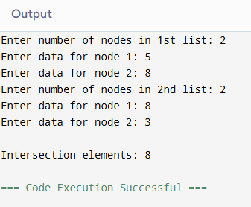
EX.NO:26 IMPLEMENT A C PROGRAM TO PERFORM LINKED LIST – INSERTION
#include <stdio.h>
#include <stdlib.h>
struct node {
int data;
struct node *next;
};
int main() {
struct node *head = NULL, *newnode, *temp;
int n, i, val;
printf("Enter number of nodes: ");
scanf("%d", &n);
for(i = 0; i < n; i++) {
newnode = (struct node*)malloc(sizeof(struct node));
printf("Enter data for node %d: ", i + 1);
scanf("%d", &val);
newnode->data = val;
newnode->next = NULL;
if(head == NULL)
head = temp = newnode;
else {
temp->next = newnode;
temp = newnode;
}
}
newnode = (struct node*)malloc(sizeof(struct node));
printf("Enter data to insert: ");
scanf("%d", &newnode->data);
newnode->next = NULL;
temp->next = newnode;
printf("\nLinked List after insertion: ");
temp = head;
while(temp != NULL) {
printf("%d ", temp->data);
temp = temp->next;
}
return 0;
}
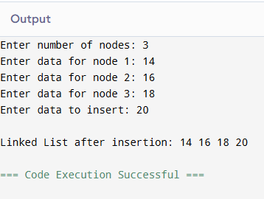

EX.NO:27 IMPLEMENT A C PROGRAM TO REVERSE – SLL
#include <stdio.h>
#include <stdlib.h>
struct node {
int data;
struct node *next;
};
int main() {
struct node *head = NULL, *newnode, *temp;
struct node *prev = NULL, *next = NULL, *current;
int n, i;
printf("Enter number of nodes: ");
scanf("%d", &n);
for(i = 0; i < n; i++) {
newnode = (struct node*)malloc(sizeof(struct node));
printf("Enter data for node %d: ", i + 1);
scanf("%d", &newnode->data);
newnode->next = NULL;
if(head == NULL)
head = temp = newnode;
else {
temp->next = newnode;
temp = newnode;
}
}
printf("\nOriginal Linked List: ");
temp = head;
while(temp != NULL) {
printf("%d ", temp->data);
temp = temp->next;
}
current = head;
while(current != NULL) {
next = current->next;
current->next = prev;
prev = current;
current = next;
}
head = prev;
printf("\nReversed Linked List: ");
temp = head;
while(temp != NULL) {
printf("%d ", temp->data);
temp = temp->next;
}
return 0;
}
